- There are some fruits with berry ending. Find them and write them on the lines.

lbue _________________
pars _________________
twras _________________ BERRY
ckabl _________________
nacr _________________
ooseg _________________
ldeer __________________

- Picture dictionary. Write the English names from the previous exercise under the pictures, then complete them with their Hungarian names.
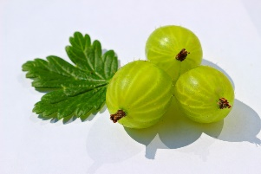
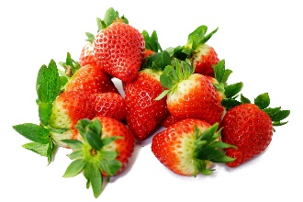
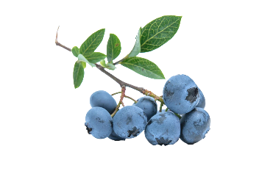

_________________________ _________________________ ________________________
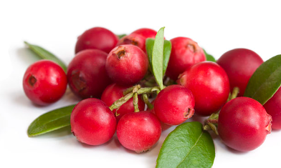
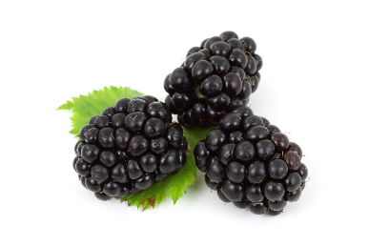

____________________________ ___________________________
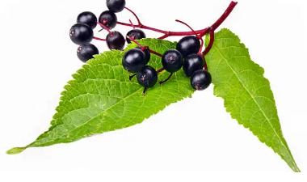
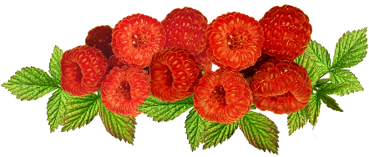

_____________________________ ___________________________
•áfonya •eper • szeder •büszke •málna •bodzabogyó •vörös áfonya

Find the berry that you can’t eat. You can just cook it and make jam.
It’s a _______________________________

