Szitakötő 74. Beküldő: Koncz Péter

About the Kultainen omenapirakka
Here you can find the secret recipe of the famous Kultainen omenapirakka:
Ingredients:
3 large golden apples
300 gr fruity flour
200 gr brilliant butter
100 gr shiny sugar
some wonderful water
Instructions:
1 Peel the apples and slice them.
2 Put the apples in a saucepan with a little water and 50 gr of the sugar. Boil the apples for ten minutes.
3 Put the flour, the butter and the rest of the sugar into a bowl. Mix them with a fork.
4 Pour the cooked apples into a dish.
5 Cover the apples with the flour, butter and sugar mixture.
6 Put the dish into the oven at 180 degrees Celsius for 30 minutes.
7 Serve the cake with ice cream.
The recipe is based on: Hutchinson, Tom: Project 2, Oxford, 4th ed., 50.o.
Task:
As you can see, some word are highlighted in the recipe. Match these words with the pictures by writing them into the word grid. What word is hidden in the grid?
1 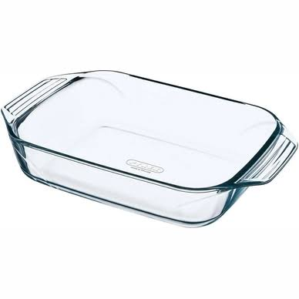 2  3 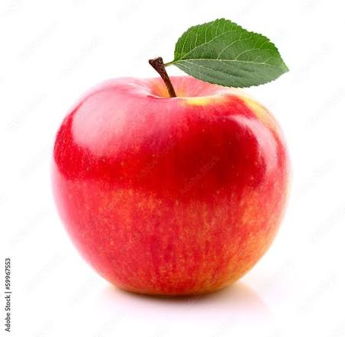

4 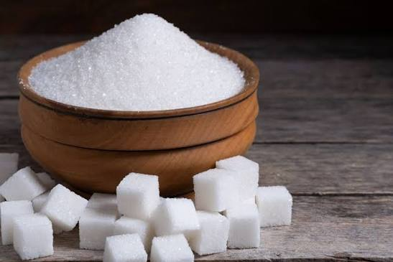 5 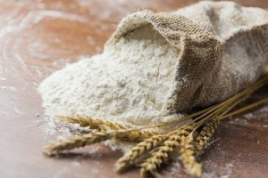 6 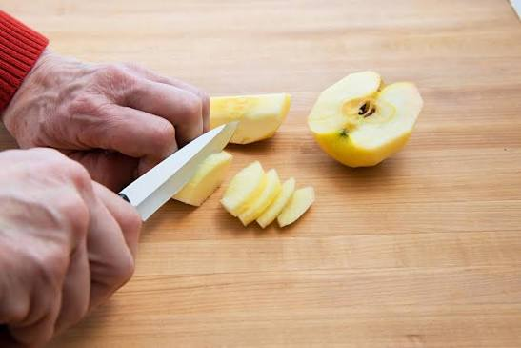

7 8 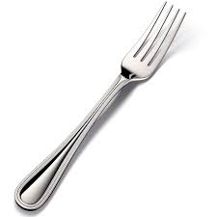 9 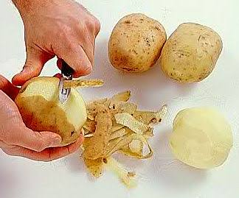
1
2
3
4
5
6
7
8
9

Megoldás:
 |  |  |  | 1 | D | I | S | H
 |  |  |  | 2 | W | A | T | E | R
 |  |  |  | 3 | A | P | P | L | E
4 | S | U | G | A | R
 |  |  |  | 5 | F | L | O | U | R
 | 6 | S | L | I | C | E
 |  |  |  | 7 | A | P | P | L | E
 | 8 | F | O | R | K
 |  |  | 9 | P | E | E | L

